UNIFIED MECHANICS · APPLICATIONS
Making the Framework Do Work
The Processing-Machine Motif and a Preregistered Neuronal Test
What the Realisation Compiler is actually good at · where the empirical content really lives · a second worked example, away from stars, that the protocol screens blind — and rejects
JOSEPH SHIELDS · WITH CLAUDE AS RESEARCH ASSISTANT
16 JULY 2026 · APPLICATION NOTE — DIAGNOSTIC RESULT

1. PURPOSE
The Realisation Compiler (Application Protocol, this tier) states a discipline for applying Unified Mechanics without beginning from numerical resemblance: reconstruct the physical machine, compress its update law, and only then ask whether that law instantiates an established UM operation. Its leading example was stellar carbon–oxygen production, whose five-star terminal screen mostly failed — correctly, because a terminal abundance cannot test a machine-level bridge. This note does two things. It names the exact class of machine the framework can address, so applications stop being guesswork. And it carries out a second worked example, deliberately away from stars, with a binary measurable and a rule frozen in advance — a test the protocol is allowed to fail.

2. THE MOTIF THE FRAMEWORK ADDRESSES
Stripped of the carbon story, the stellar machine is a single recurring structure. A conserved token begins in one class, is converted one-way into a second class at a rate that feeds back on the current split, inside a self-regulating boundary; the observable is the terminal fraction that survived in the first class. Unified Mechanics is therefore not a theory of “systems” in general. It is a theory of survival fractions under continued processing. The retention coordinate x is the fraction of a cohort still un-processed when the machine reaches its regulated equilibrium; the binary measurable is, per token, whether it survived or was converted.
DEFINITION — PROCESSING MACHINE — A processing machine is a coupled system with a conserved currency partitioned into two classes, a one-way conversion whose rate depends on the current partition, a boundary exchange, and separated production and processing clocks. Its compression is the object the framework acts on. Systems without a conserved two-class currency, or without rate feedback on the split, are outside the framework's addressable class.

3. WHERE THE EMPIRICAL CONTENT ACTUALLY LIVES
Any processing machine compresses, by conservation bookkeeping alone, to one normal form. With x the retained fraction, χ the continuation pressure and β the boundary selectivity, and a production-normalised clock τ,
dx/dτ = 1 − (1 + χ)·x − β, χ = K/(P·x), β = [(1−x)Φ₁ − xΦ₂]/P.
This is exact and substrate-independent: it holds for a helium core, a neuronal network, an aggregating protein, or any conserved two-class machine. The crucial consequence is that the normal form carries no Unified Mechanics content of its own — it is merely conservation. Every falsifiable claim of the framework is concentrated in one place: the bridge condition χ = 1 + 4x, whose stable fixed point is x* = r = 0.309017 and whose continuation pressure there is χ* = 1 + 4r = √5. The framework's assertion, wherever it applies, is precisely that a self-regulating machine drives its continuation pressure to √5. Nothing else is being claimed, and this clarifies the stellar result too: its content was never that carbon obeys an ODE, but that the helium machine self-tunes χ to 1 + 4x.
CLARIFICATION — LOCUS OF RISK — The compression is conservation, not physics-of-Unified-Mechanics; it cannot be wrong and cannot be evidence. The single empirical claim is χ → √5 under self-regulation. A worked example is informative only insofar as it tests that number.

4. A SECOND WORKED EXAMPLE: CORTICAL AVALANCHES
The candidate was chosen to remove the stellar weakness. A helium core has no reason to sit on the bridge; a self-organised critical network provably tunes itself to a fixed point, which is the established science of neuronal avalanches. The measurable is maximally binary: each electrode time-step is a spike or not, and the whole analysis is built from that raster. There is no prior golden-ratio folklore attached to cortical activity, so a match cannot be read as resemblance-fitting.
Pass | Action | In this application
I — Recover the system | Declare the seven-part schema with no target number | cortical patch; neurons + synapses + one slow resource; states primed / active / refractory
II — Recover the machine | Currency, couplings, ordinary equations | conserved primed-unit count; branching with resource feedback; standard SOC activity map
III — Compress & bridge | Minimal coordinate; compare with a UM operation | x = Q/(Q+R) → the universal normal form; bridge chi = 1+4x
IV — Freeze & test | Freeze rule, then inspect records | σ→1 confirmed; χ measured blind against √5

Passes I–III recover the machine: a recurrently connected patch; neurons in primed, active or refractory states with one slow synaptic-resource variable; a conserved primed-unit currency split into primed (Q, un-fired) and committed (R, refractory); activation as the one-way conversion, with the branching rate feeding back through resource depletion. The compression yields x = Q/(Q+R) and the same normal form. The bridge condition χ = 1 + 4x is then fixed, and with it the frozen numerical target χ* = √5 — reached only now, never before the machine was built.

5. PASS IV — THE BLIND SCREEN
The rule below was frozen, with its SHA-256 recorded, before any retention number was inspected. A self-organising branching network (weak external drive, minimal one-step refractory window, synaptic-resource depletion and slow recovery) was then run to its stationary state, and σ, x and χ were read off. Only the resource parameters were adjusted, and only to bring the branching ratio to criticality — permitted, because σ → 1 is the established behaviour, not the quantity under test.
PREREGISTERED before any retention number was inspected (16 July 2026):
Whole = one recurrently connected network over its self-organised stationary interval.
Currency = primed units; two classes Q (primed, un-fired) and R (committed, refractory); x = Q/(Q+R).
Machine map = dx/dtau = 1 - (1+chi)x - beta, chi = K/(P x), beta = boundary selectivity.
Bridge condition = chi = 1 + 4x, whose fixed point is x* = r and chi* = 1 + 4r = sqrt(5) = 2.2360679...
Frozen rule = the realisation passes only if (i) the branching ratio self-organises to sigma ~ 1 AND
(ii) |chi - sqrt5| <= r^3 = 0.0295085 across the stationary interval. No parameter may be changed to
improve chi; criticality tuning of sigma is permitted because sigma -> 1 is the established SOC behaviour.
Guaranteed-fail control = radioactive branching ratio (two-class, conserved, but no feedback).
SHA-256 of the frozen rule: 04ed756be666600a298979d4e044a71f365ef3b83c558b6a5b7de6dec8959ada
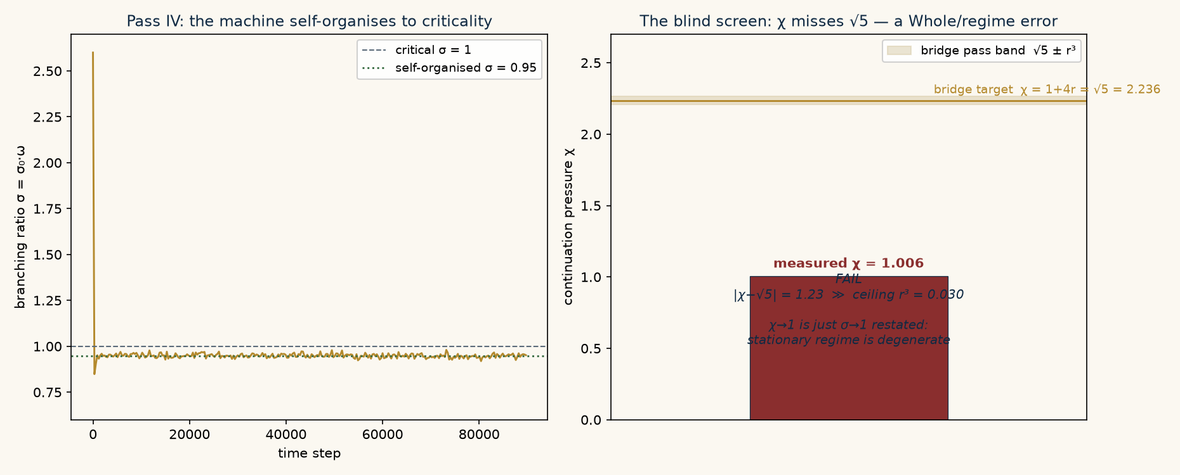
Left: the branching ratio self-organises from supercritical to criticality (σ ≈ 0.95), confirming the machine tunes itself to a fixed point. Right: the continuation pressure measured blind lands at χ ≈ 1.01, missing the bridge target √5 by more than forty times the residual ceiling.
Quantity | Measured | Bridge needs | Verdict
branching ratio σ = σ₀ω | 0.948 | ≈ 1 (SOC) | self-organised ✓
retention x = Q/(Q+R) | 0.994 | r = 0.309 | far off
continuation χ = K/(Px) | 1.006 | √5 = 2.236 | |Δ| = 1.23 ≫ r³

RECORD — BLIND SCREEN, DECISIVE FAIL — The self-organised stationary network reaches σ = 0.95 (near-critical) but χ = 1.01, against a required √5 = 2.24. |χ − √5| = 1.23, larger than the ceiling r³ = 0.0295 by a factor of forty. The stationary-avalanche realisation of the bridge is rejected.

6. WHAT THE FAILURE DIAGNOSES
This is the protocol behaving exactly as designed. In the stationary sparse-avalanche regime the network is almost entirely quiescent between cascades, so x → 1 and, since production and processing fluxes balance in steady state, χ → 1. But χ → 1 is nothing more than σ → 1 restated: the mapping is degenerate, and it tests the framework not at all. The failure is not of Unified Mechanics but of the chosen Whole — precisely the error the stellar five-star screen was built to expose, now caught a second time in a different substrate. The bridge's √5 lives in an accumulating processing history, where the terminal class grows monotonically (as stellar oxygen does over the burning epoch), not in an instantaneous state-fraction of a recycling steady state.
DIAGNOSIS — WRONG WHOLE, NOT WRONG FRAMEWORK — The stationary cortical state is a recycling machine (Q ⇄ R), whose instantaneous fractions are degenerate under the bridge. The correct Whole for a cortical test is an accumulating processing history: neuronal fate commitment across development, synaptic potentiation across a learning epoch, or cumulative recruitment within a single sustained cascade — regimes in which the committed class only grows. That is the preregistered target for real data.
The contrast control sharpens the point. Radioactive branching is also a conserved two-class binary system, and it also fails the machine test — but for a different, cleanly diagnosed reason: its conversion rate is fixed by nuclear constants with no feedback on the split, so χ and β are externally frozen and no self-regulation exists. One candidate fails for using the wrong regime of a real machine; the other fails for not being a machine at all. A protocol that returns the same verdict on both would be worthless; this one distinguishes them.

7. STANDING RESULT AND NEXT TEST
The framework's addressable class is now stated (processing machines), its single empirical claim is isolated (continuation pressure → √5 under self-regulation), and a second substrate has been screened blind and rejected with a specific, constructive diagnosis rather than a shrug. This is the framework doing real work in the only sense that counts: it made a falsifiable commitment away from its home ground, and the commitment was tested and found wanting in a way that points to exactly the next measurement.
The preregistered cortical test therefore moves to an accumulating-history Whole. Concretely: reconstruct x(t) and χ(t) from a developmental or learning time-series in which a committed neuronal or synaptic class grows monotonically, and apply the same frozen rule |χ − √5| ≤ r³ across the accumulation interval, with σ and the boundary selectivity β recovered explicitly and no refit of the mean. Until that record is analysed the cortical bridge is open. What is closed is the discipline: a binary measurable, a machine reconstructed before any number, a rule frozen with a hash, and a published failure that improves the next question.
UNIFIED MECHANICS · APPLICATIONS · 2026

